**1. interdiction**

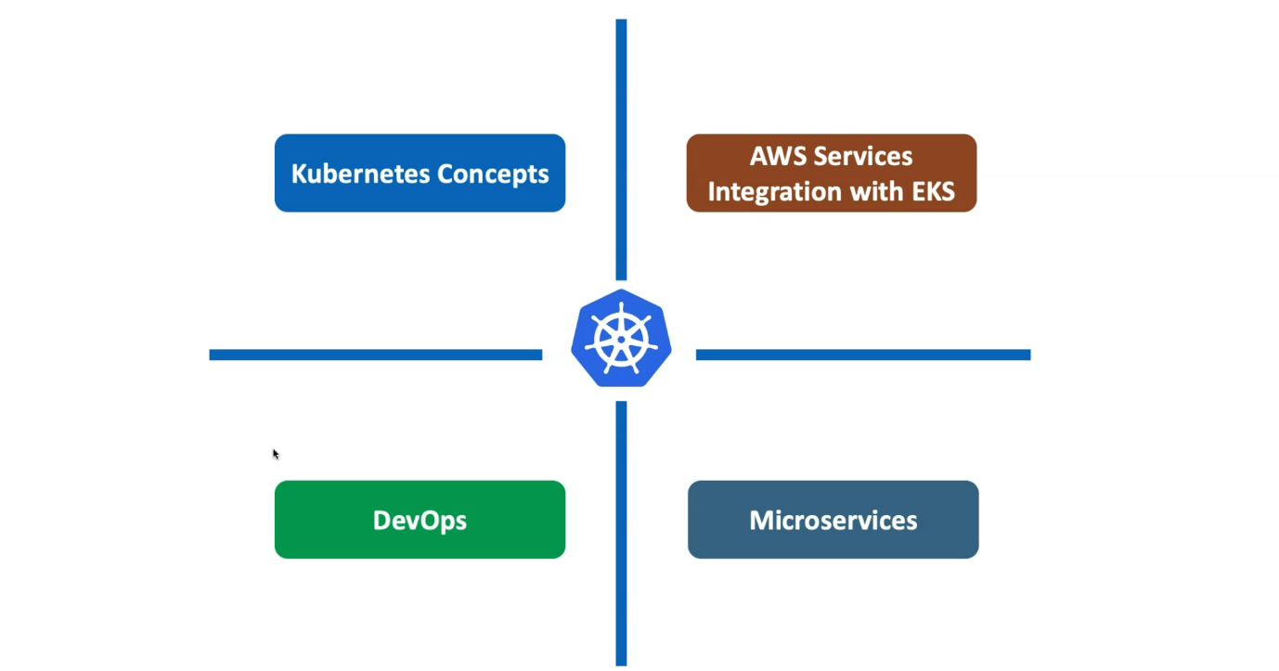

--- we have divided the topics into 4 major sections.

1. kubernetes concepts.
2. Aws services integrations with EKS. (What all aws services we can use with elastic kubernetes service of aws)
3. DevOps
4. Microservices.

**Concepts covered under kubernetes course**

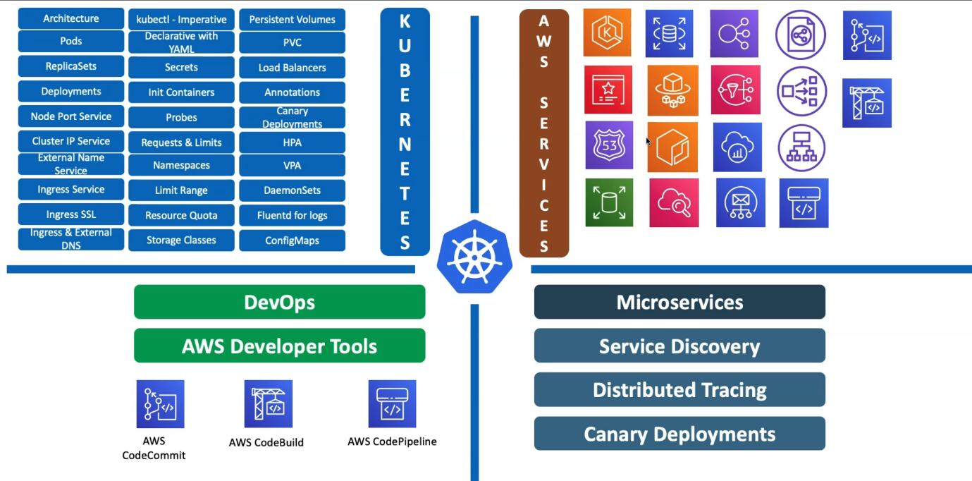

--- **kubernetes concepts covered** - So close to 30 kubernetes concepts are covered as part of this entire course. and whenever we are writing these concepts related Yamal declarative files, we are going to do it live template writing sections wherever it is required.

--- **AWS services** - So, in addition to that, we also cover integration with close to 18 or 19 A.W.S services. in relation with the EKS.

--- **DevOps, aws developer tool** - So, from devops perspective, using kubernetes code services, we have implemented a devops pipeline to understand it better for both applications and also the kubernetes manifest.

So, which means like if you make any change to your kubernetes manifest and then check in the code then that code will get deployed to your kubernetes cluster.

--- If you make any changes to your application and then check in your application code. So, it will build a new Docker image then deployed to the kubernetes cluster. So, both ways the pipeline is built for you.

--- **Microservices** - So from micro services perspective, the core concepts in relation with kubernetes will be Service discovery, distributed tracing and Cannady deployments.

**Docker fundaments**

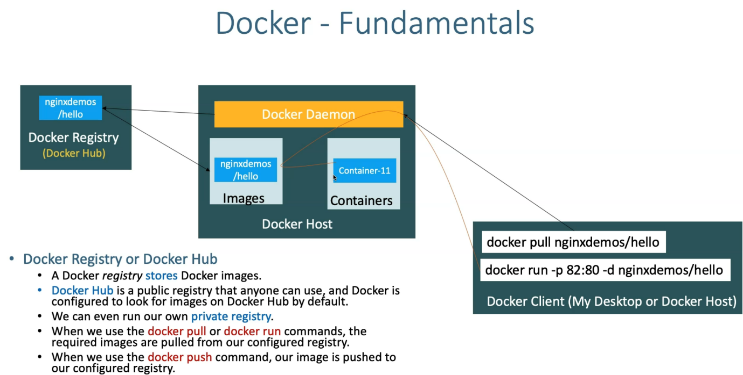

--- **note** - So, we are going learn both docker and kubernetes fundamentals in the fundamentals section.

**Kubernetes fundamentals**

**Kubernetes – imperative & declarative way**

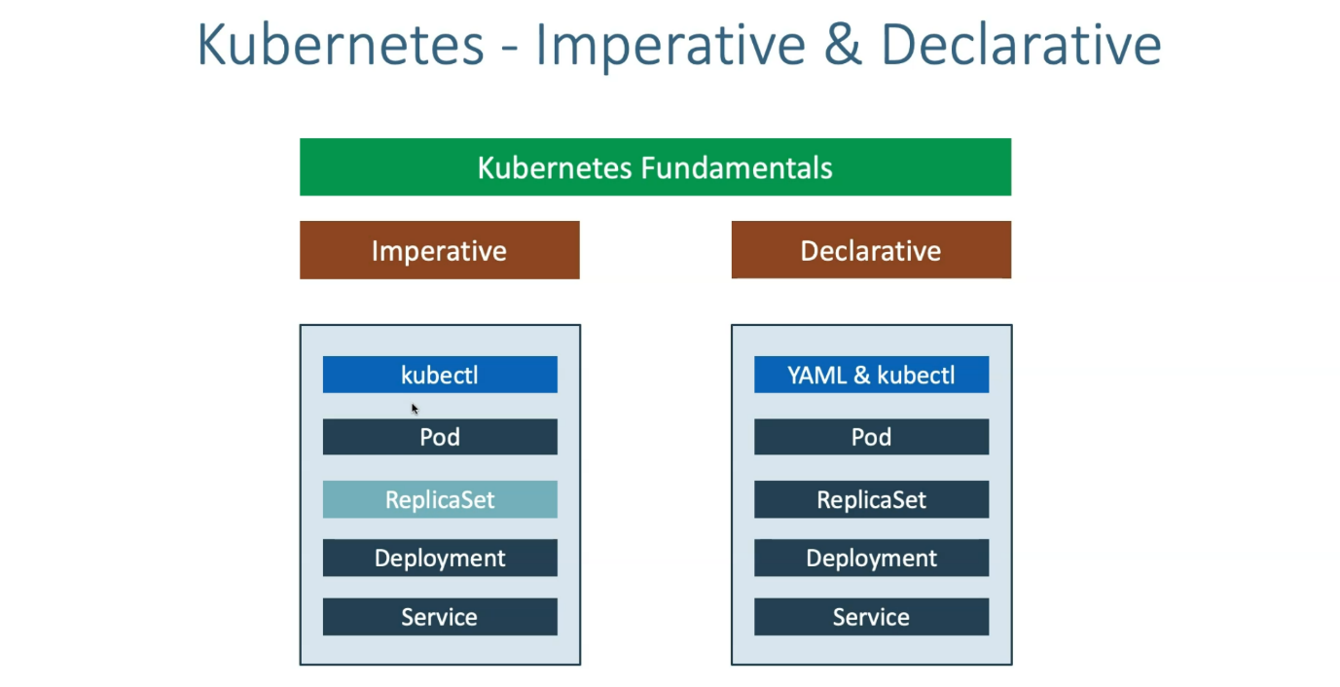

--- we will primarily focus on implementing kubernetes concepts using Imperative and declarative way.

--- So here we do lot of live templates writing in the declarative way and lot of kubernetes commands in the imperative section and then get full idea about pod, replicaset, deployment, service.

**EKS Storage, EBS CSI driver**

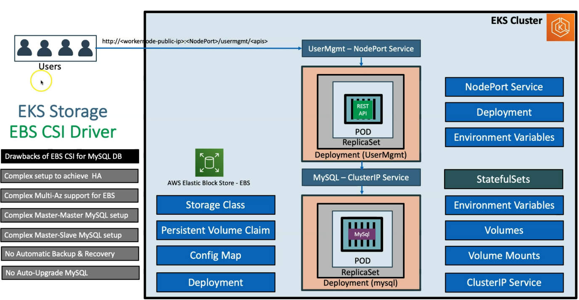

--- **note** - we will start with in this course with the EKS storage with EBS CSI Driver, which is Elastic block storage. As part of that, we'll learn how to write a deployment, how to write a mysql service, and how to write in North Port service and environmental variables, how you are going to define and volumes, volume mounts, everything. whatever is related to this respective section, we will do a live template writing.

--- understand all these concepts and provision these things from kubernetes manifest.

**Amazon RDS**

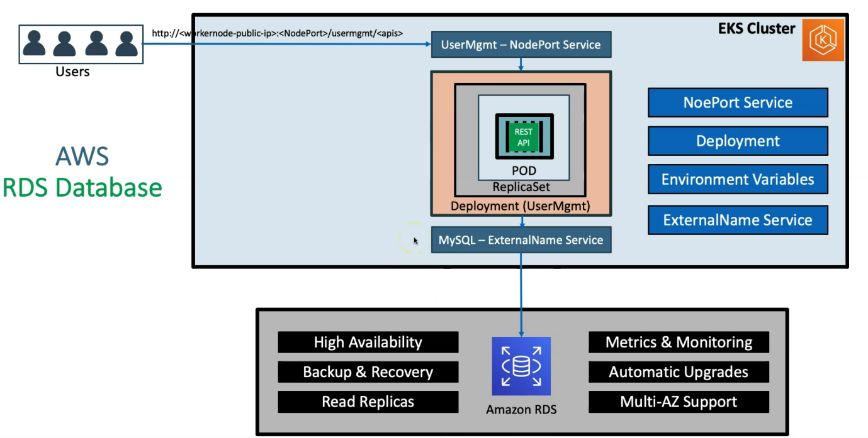

--- **note** – we completed about storage and db part.

**Load balancer**

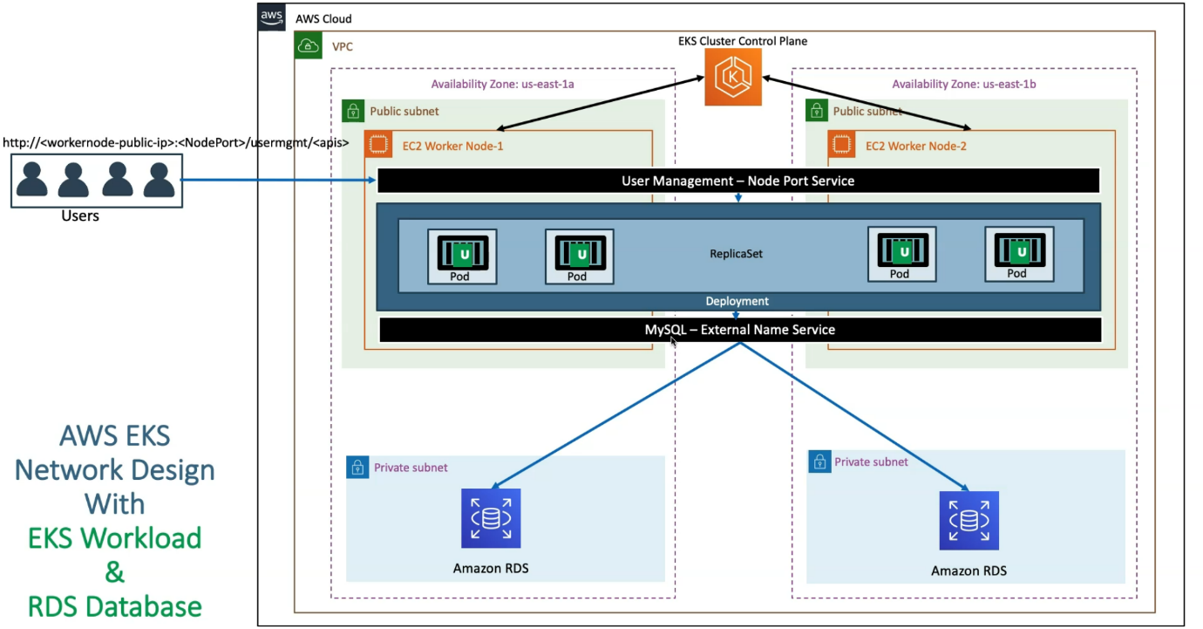

--- whatever you have implemented. It's equal a network diagram looks this way. Anyway, we know that load balances need to run on public subnets and then our workloads need to run on private subnets.

**Classic load balancer**

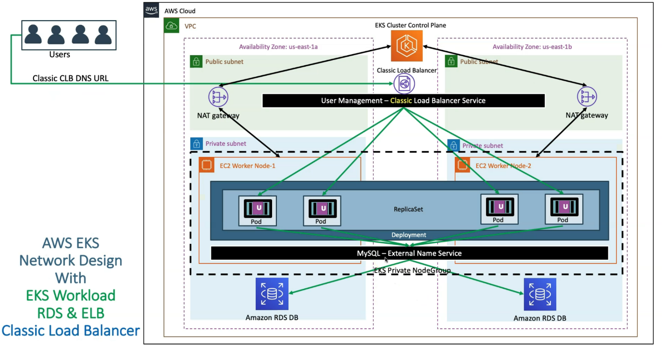

**Network load balancer**

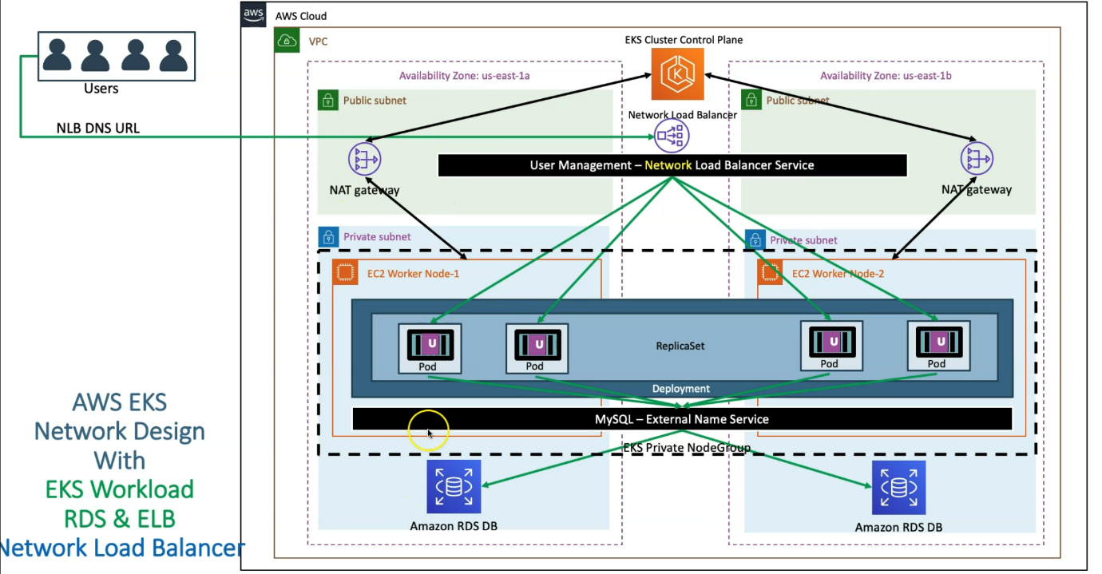

--- **note** – now we have used classic and network load balancer.

**Ingress service**

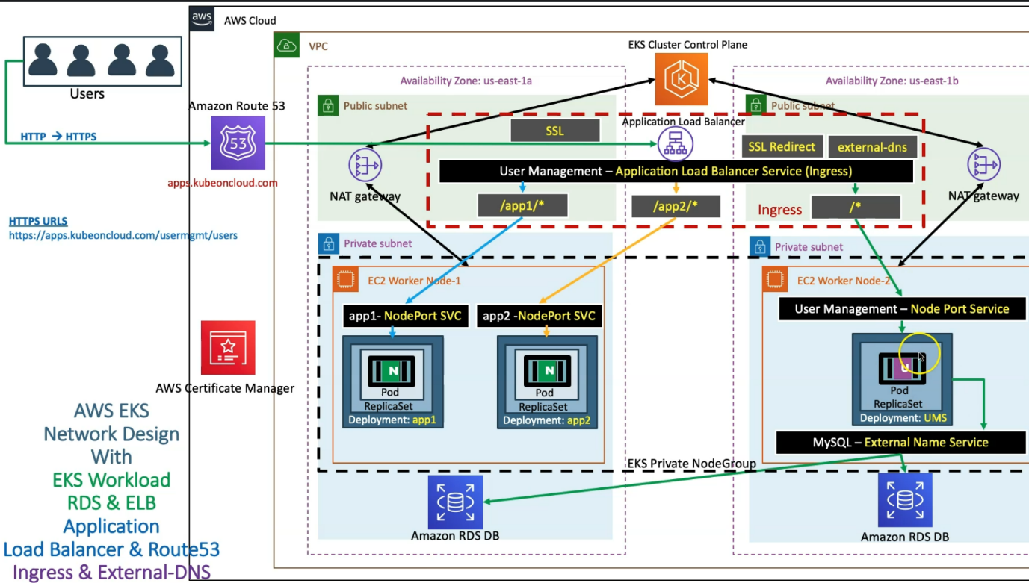

--- **note** - we are going to implement context path-based routing, three applications,

we are going to deploy and then you will implement the context path-based routing with /app1/* should go to app1, /app2/* should go to app2 and then anything other than that should go to user management micro services.

--- In addition to that, in the same Ingress service, you will implement SSL, so you'll enable the SSL for your application here.

--- you'll also implement http to https redirection using SSL redirect and finally in ingress Load Balancer we are going to implement external DNS. So external DNS, what it does is, automatically from the kubernetes manifest we are going to register your domain name in the route 53 service.

--- **note** – we have completed the db, deployment, load balancer part and what come after next is that is fargate serverless

**Fargate serverless**

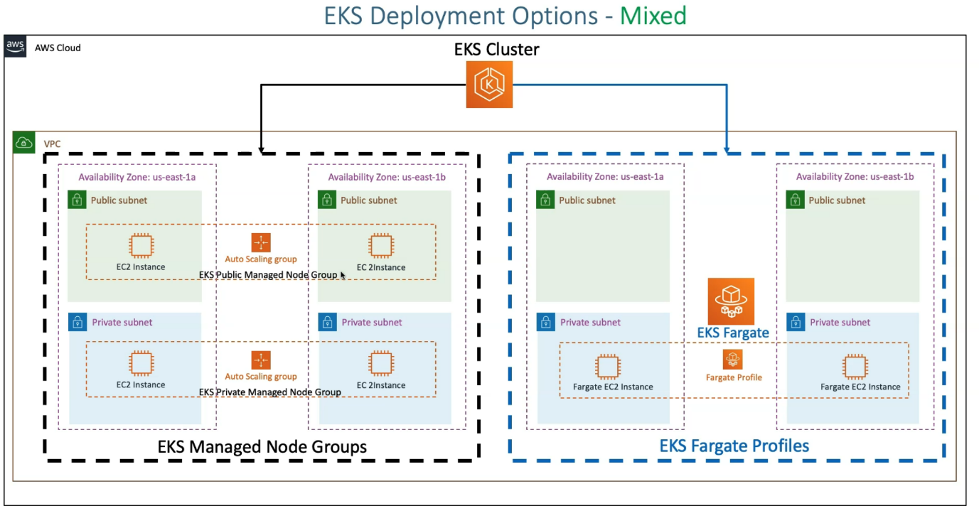

--- What we do is like a we will run our workloads in a mixed mode in such a way that we will run fewer workloads on our regular managed node groups with ec2 instances and then we'll also run kubernetes services on Fargate.

--- So, we are going to implement this with three applications app1, app2, and ums in a mixed mode deployment.

--- app1 will run on EKS managed node groups and app2 and ums will run EKS fargate profiles.

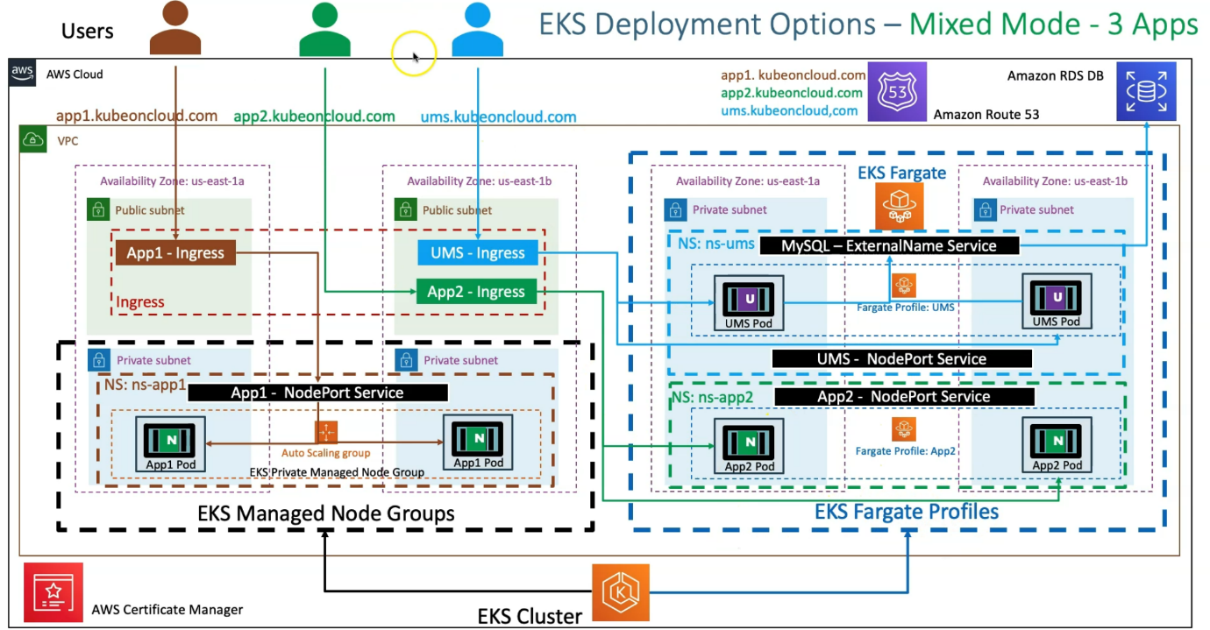

--- after this we will moved on to the elastic container registry.

**Elastic container registry in relation with EKS**

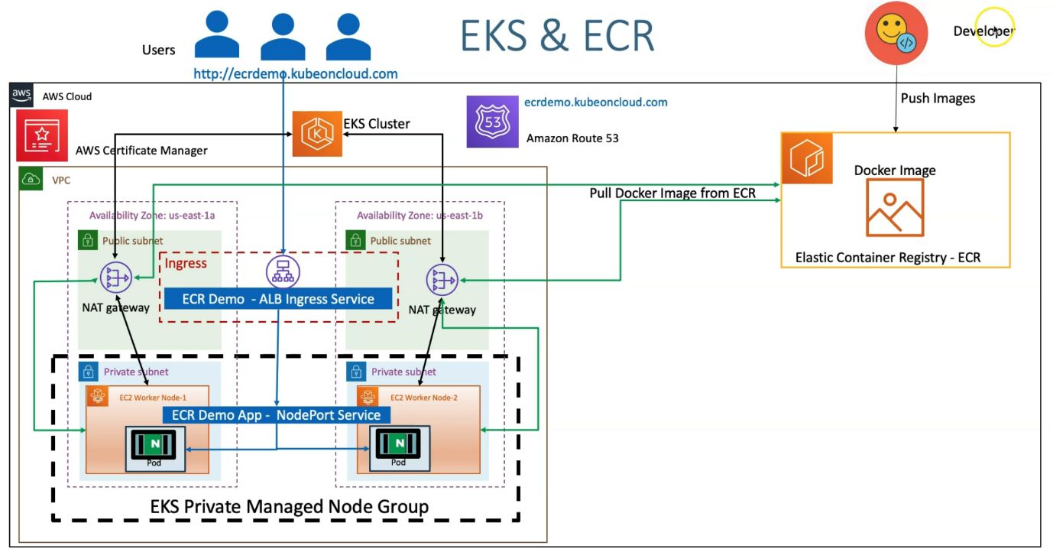

--- **note** – we are creating a new docker image and then push

it to the elastic container registry and then use that Docker image in our kubernetes cluster. we'll continue with our ingress load balancer for all these sections also.

**DevOps section**

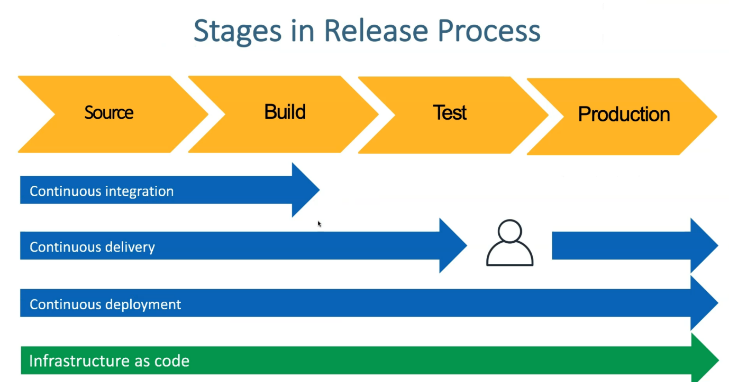

--- note – we will understand all the above concepts.

**AWS developer tools**

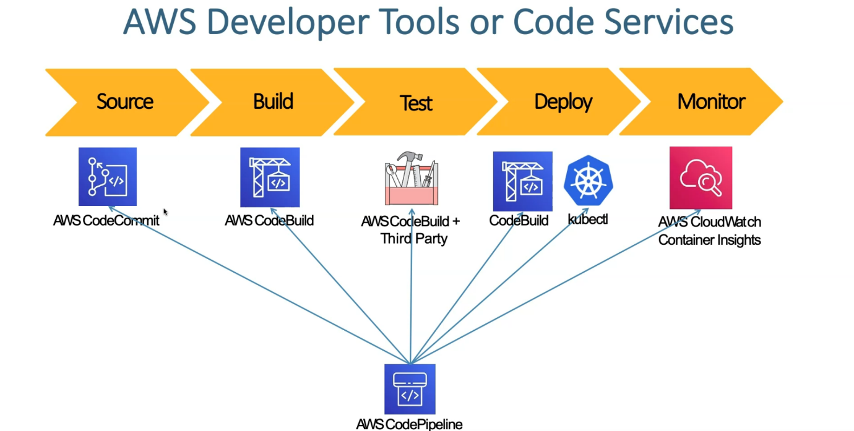

--- **note** – here we are going to learn how we are going to implement devops concepts in relation with EKS.

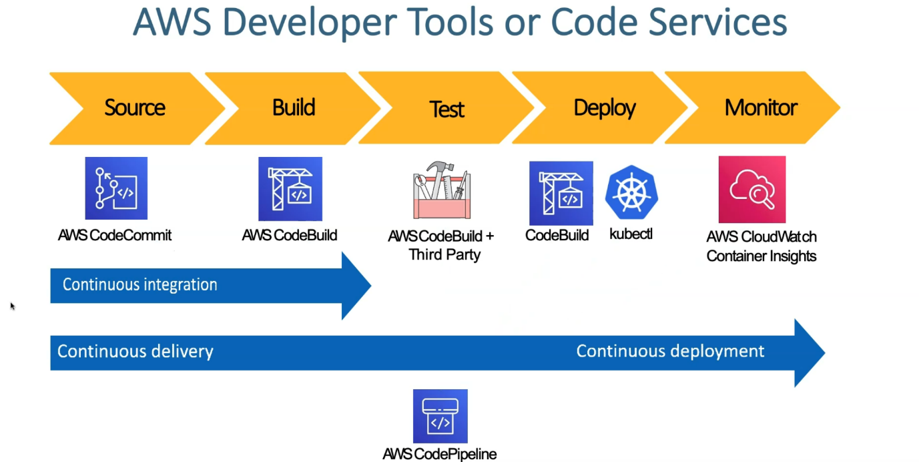

--- **note** – here we also about what is continuous integration, continuous delivery and continuous deployment.

**Micro services**

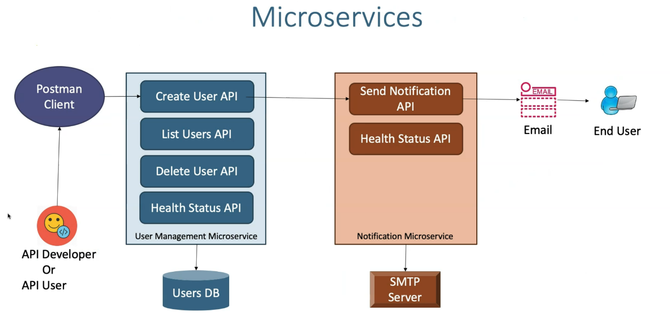

--- in section we will discuss about two independent micro services built exclusively for testing.

--- So, we are going to use these two services, user management micro service, notification micro service. So, whenever you as a developer, when you use a postman client and create a user, it will call the notification api and send an email to end user.

**Micro service deployment**

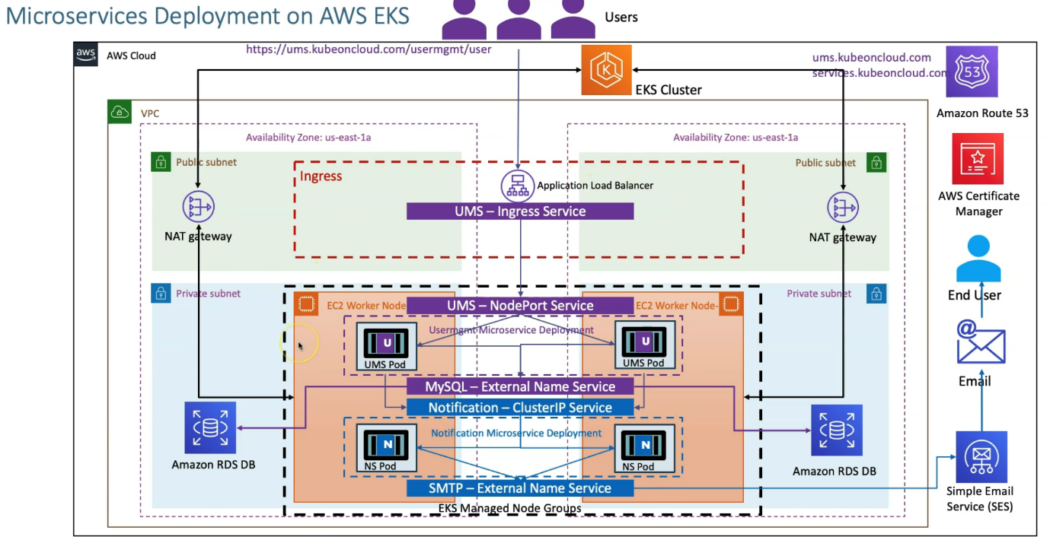

--- **note** – this is how we implemented everything from end to end.

**Kubernetes daemonsets**

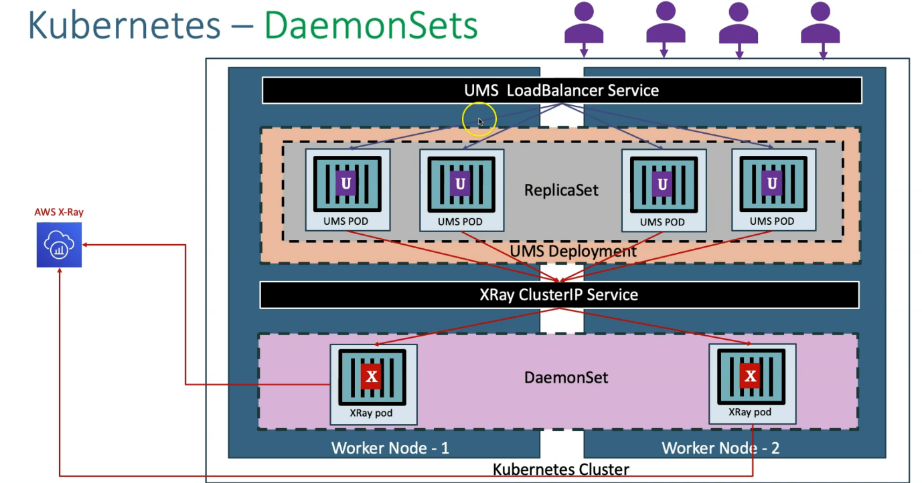

--- **note** – we will move on to the distributed tracing.

--- So far distributed tracing we need to deploy our Daemonsets with X ray pods. So, using Kubernetes daemonsets concept we are going to deploy the X ray pods.

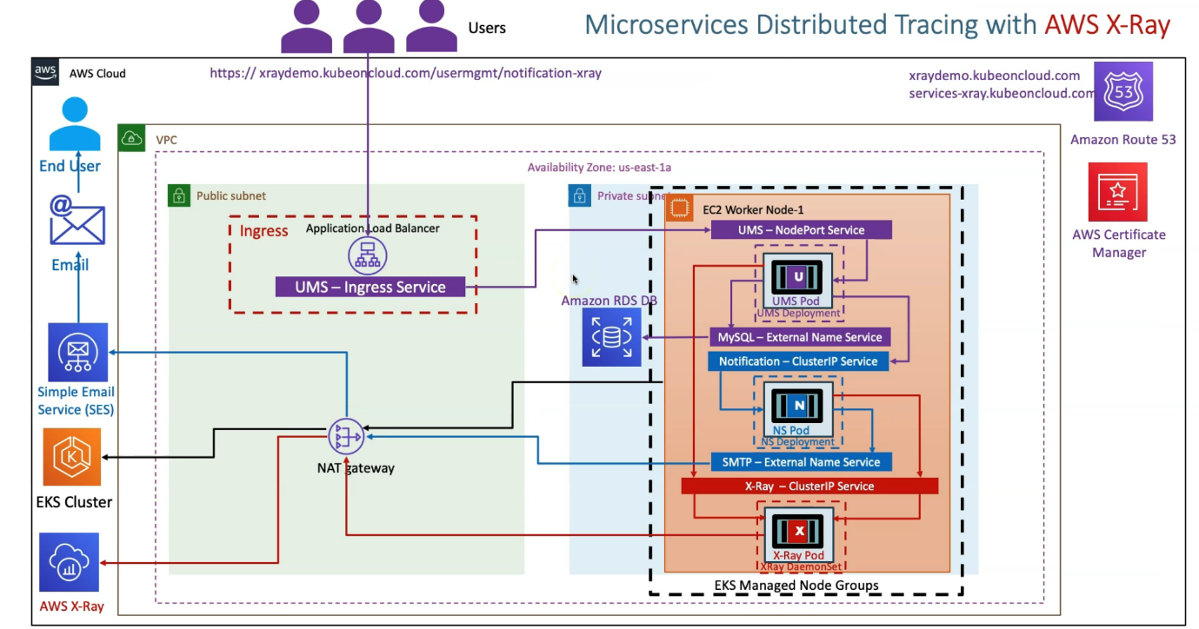

--- when you deploy those applications. how the x ray pods is going to be behave, So, using distributer tracing, we are going to see in detail.

**AWS x ray service map**

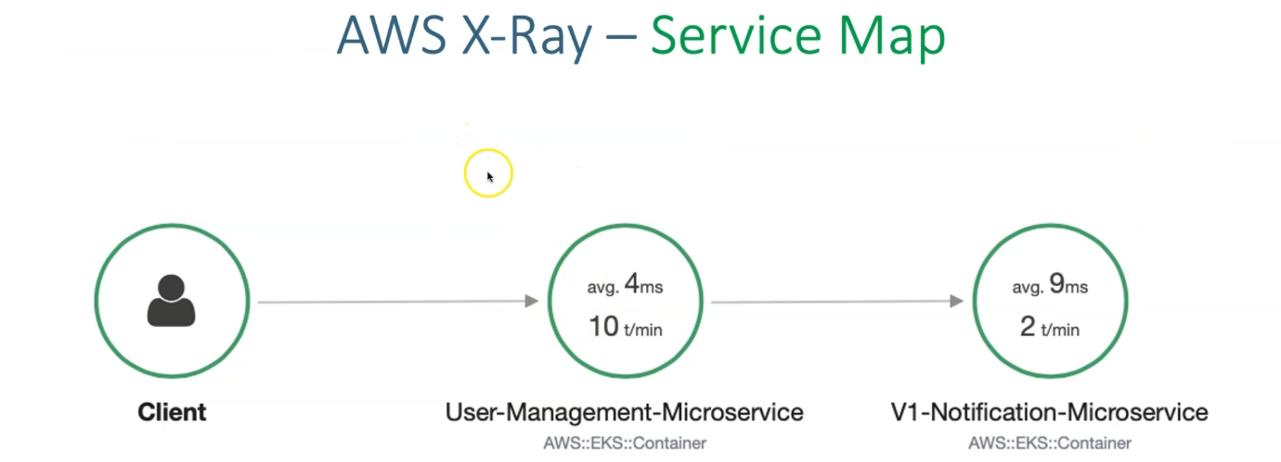

--- if the distributed tracing is enabled then you can see the service map.

--- here the request from client comes to the user management micro service and calls the notification micro service. So, everything you are going to see in details.

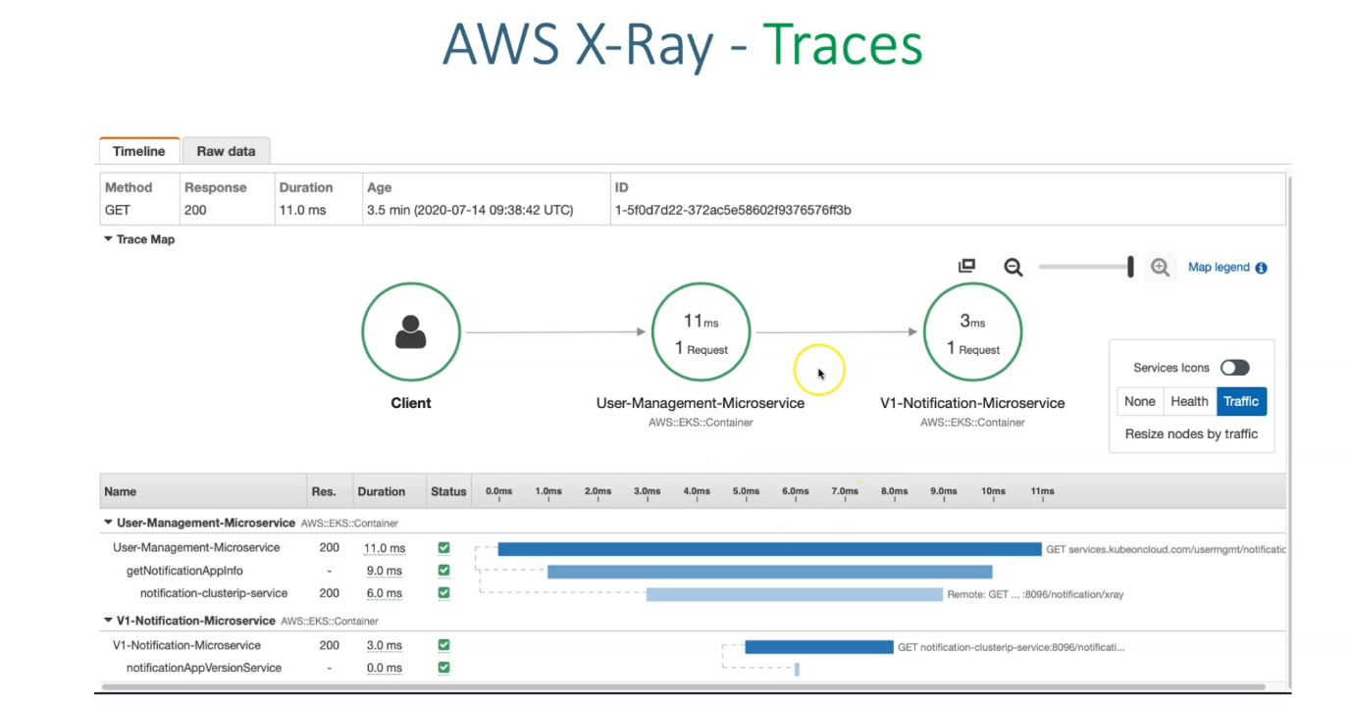

--- **User management microservice** – the request came to the user management micro services and inside of that application it went to the get notification app info and from there It went to kubernetes notification cluster ip service.

--- **v1 notification micro service** – It called the v1 notification microservice was called and also notification app service was called.

**Micro service canary deployment**

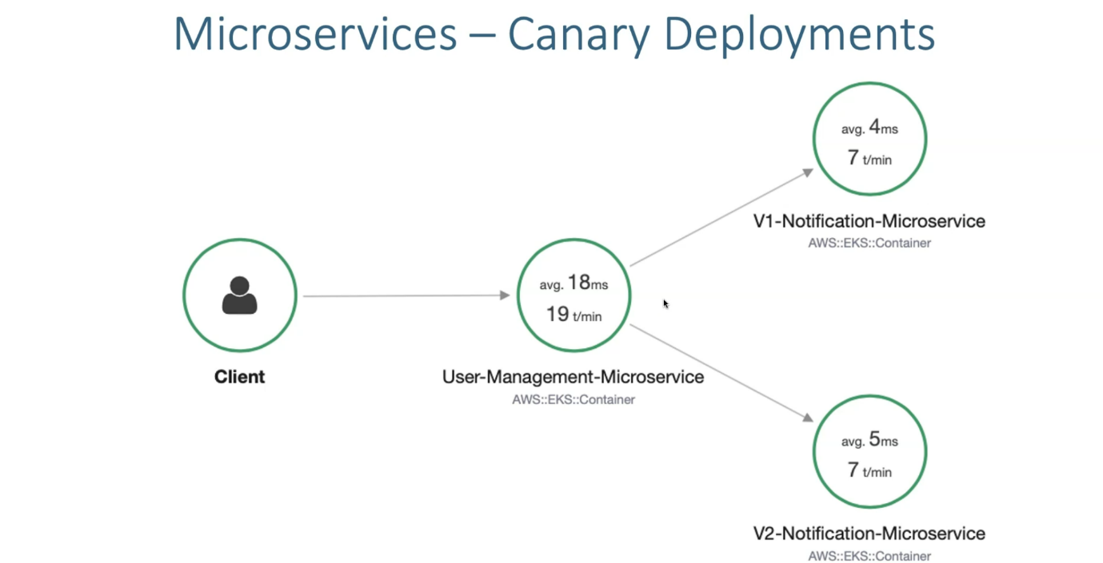

--- finally for Micro Services, we are also going to do the Canary deployment. So, whenever we call that user management micro service, there will be two versions of notification services will be live and the traffic will be distributed based on how much we configure. Like 50, 50 or 25, 75.

**How auto scaling works**

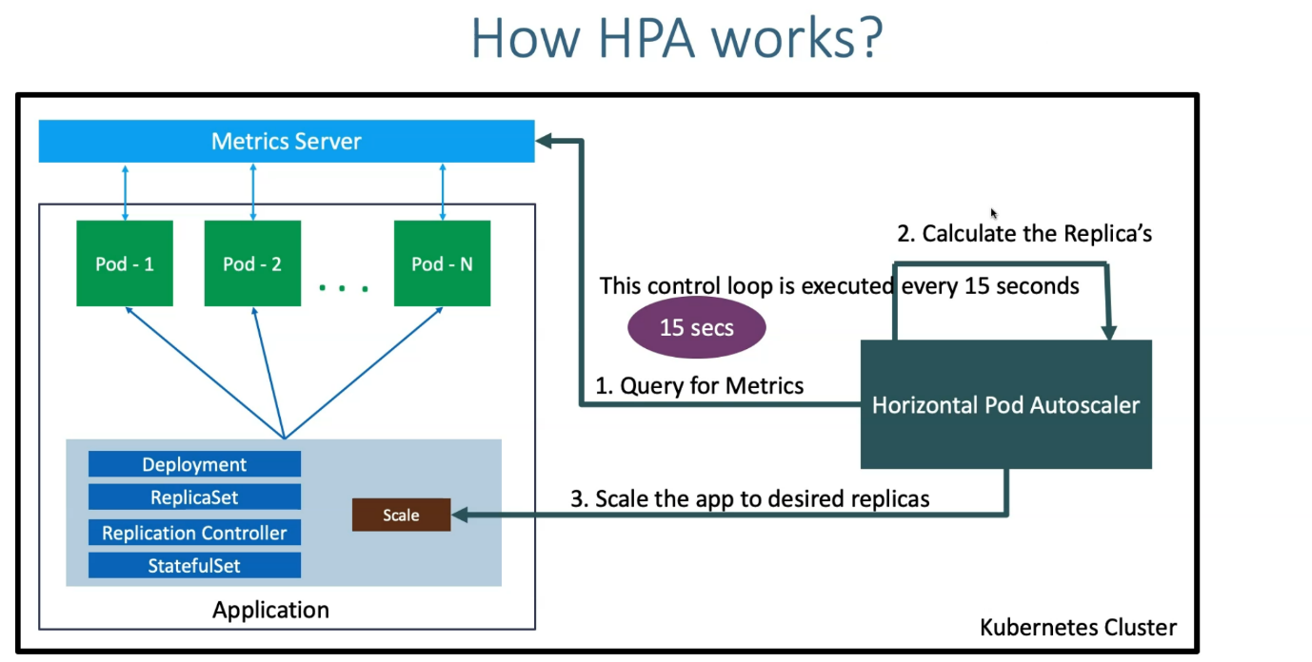

--- we will move on to the horizontal auto scalar, vertical auto scalar, cluster auto scalar.

**Container insights**

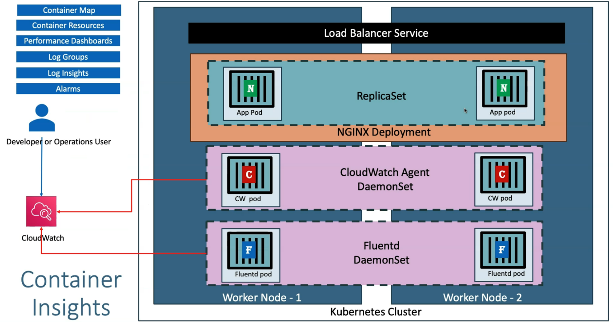

--- this section is for kubernetes monitoring and logging. We will use cloud watch daemonsets agent in our kubernetes cluster to get the metrics of our cluster with application deployed inside of that.

--- In addition to that, we are also going to deploy **Fluednt** daemonsets which will get the application logs and kubernetes cluster logs for us inside of cloud watch.

**Cloud watch container insights Map**

